Name: ______________________________ Date: ______________________
Class: _______________________________ Period: ____________________

An Introduction to Metabolism
Independent Questions 9-15

9. Which of the following is true of enzymes?
A) Enzyme function is increased if the 3- D structure or conformation of an enzyme is altered.
B) Enzyme function is independent of physical and chemical environmental factors such as pH and temperature.
C) Enzymes increase the rate of chemical reaction by lowering activation energy barriers.
D) Enzymes increase the rate of chemical reaction by providing activation energy to the substrate.
Bloom's Taxonomy: Knowledge/Comprehension
Section: 8.4

10. Which of the following is true when comparing an uncatalyzed reaction to the same reaction with a catalyst?
A) The catalyzed reaction will be slower.
B) The catalyzed reaction will have the same ∆G.
C) The catalyzed reaction will have higher activation energy.
D) The catalyzed reaction will consume all of the catalyst.
Bloom's Taxonomy: Knowledge/Comprehension
Section: 8.4

11. During a laboratory experiment, you discover that an enzyme-catalyzed reaction has a ∆G of -20 kcal/mol. If you double the amount of enzyme in the reaction, what will be the ∆G for the new reaction?
A) -40 kcal/mol
B) -20 kcal/mol
C) 0 kcal/mol
D) +20 kcal/mol
Bloom’s Taxonomy: Application/Analysis
Section: 8.4
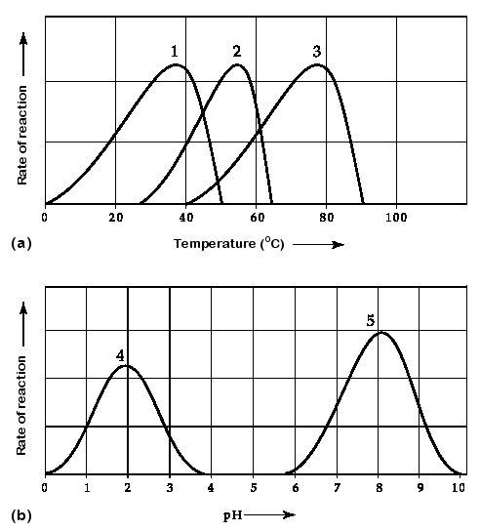
Activity of various enzymes at various temperatures (a) and at various pH (b).

12. Which curves on the graphs may represent the temperature and pH profiles of an enzyme taken from a bacterium that lives in a mildly alkaline hot springs at temperatures of 70°C or higher?
A) curves 1 and 5
B) curves 2 and 5
C) curves 3 and 4
D) curves 3 and 5
Bloom's Taxonomy: Application/Analysis
Section: 8.4

13. Which temperature and pH profile curves on the graphs were most likely generated from analysis of an enzyme from a human stomach where conditions are strongly acid?
A) curves 1 and 4
B) curves 1 and 5
C) curves 2 and 4
D) curves 3 and 4
Bloom's Taxonomy: Application/Analysis
Section: 8.4

14. Protein kinases are enzymes that catalyze phosphorylation of target proteins at specific sites, whereas protein phosphatases catalyze removal of phosphate(s) from phosphorylated proteins. Phosphorylation and dephosphorylation can function as an on-off switch for a protein's activity, most likely through
A) the change in a protein's charge leading to a conformational change.
B) the change in a protein's charge leading to cleavage.
C) a change in the optimal pH at which a reaction will occur.
D) a change in the optimal temperature at which a reaction will occur.
Bloom’s Taxonomy: Synthesis/Evaluation
Section: 8.5

15. Get ready for this one…

A number of systems for pumping ions across membranes are powered by ATP. Such ATP-powered pumps are often called ATPases, although they do not often hydrolyze ATP unless they are simultaneously transporting ions. Because small increases in calcium ions in the cytosol can trigger a number of different intracellular reactions, cells keep the cytosolic calcium concentration quite low under normal conditions, using ATP-powered calcium pumps. For example, muscle cells transport calcium from the cytosol into the membranous system called the sarcoplasmic reticulum (SR). If a resting muscle cell's cytosol has a free calcium ion concentration of 10-7 while the concentration in the SR is 10-2, then how is the ATPase acting?
A) ATPase activity must be powering an inflow of calcium from the outside of the cell into the SR.
B) ATPase activity must be transferring i to the SR to enable this to occur.
C) ATPase activity must be pumping calcium from the cytosol to the SR against the concentration gradient.
D) ATPase activity must be opening a channel for the calcium ions to diffuse back into the SR along the concentration gradient.
Bloom's Taxonomy: Synthesis/Evaluation
Section: 8.3

