Name: ______________________________ Date: ______________________
Class: _______________________________ Period: ____________________

Viruses + Biotechnology + Genome Evo
Independent Questions 9-20
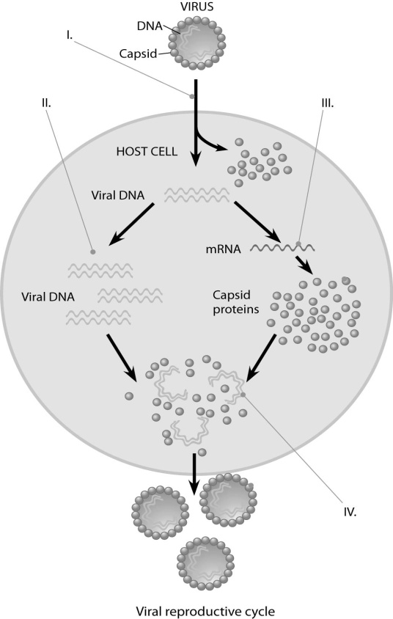

9. In the figure, at the arrow marked II, what enzyme(s) are being utilized?
A) reverse transcriptase
B) viral DNA polymerase
C) host cell DNA polymerase
D) host cell RNA polymerase
Bloom's Taxonomy: Knowledge/Comprehension
Section: 19.2

10. In the figure, when new viruses are being assembled at the point marked IV, what mediates the assembly?
A) host cell chaperones
B) assembly proteins coded for by the host nucleus
C) assembly proteins coded for by the viral genes
D) nothing; they self-assemble
Bloom's Taxonomy: Knowledge/Comprehension
Section: 19.2

11. Which of the following statements describes the lysogenic cycle of lambda (λ) phage?
A) After infection, the viral genes immediately turn the host cell into a lambda-producing factory, and the host cell then lyses.
B) Most of the prophage genes are activated by the product of a particular prophage gene.
C) The phage genome replicates along with the host genome.
D) The phage DNA is copied and exits the cell as a phage.
Bloom's Taxonomy: Knowledge/Comprehension
Section: 19.2

12. The first class of drugs developed to treat AIDS, such as AZT, were known as reverse transcriptase inhibitors. They most likely worked because they _____.
A) targeted and destroyed the viral genome before it could be reverse transcribed into DNA
B) bonded to the dsDNA genome of the virus in such a way that it could not separate for replication to occur
C) bonded to the viral reverse transcriptase enzyme, thus preventing the virus from making a DNA copy of its RNA genome
D) prevented host cells from producing the enzymes used by the virus to replicate its genome
Bloom's Taxonomy: Application/Analysis
Section: 19.2
13. What is the main structural difference between enveloped and nonenveloped viruses?
A) Enveloped viruses have their genetic material enclosed by a layer made only of protein.
B) Nonenveloped viruses have only a phospholipid membrane, while enveloped viruses have two membranes, the other one being a protein capsid.
C) Enveloped viruses have a phospholipid membrane outside their capsid, whereas nonenveloped viruses do not have a phospholipid membrane.
D) Both types of viruses have a capsid and phospholipid membrane; but in the nonenveloped virus the genetic material is between these two membranes, while in the enveloped virus the genetic material is inside both membranes.
Bloom's Taxonomy: Knowledge/Comprehension
Section: 19.1

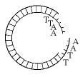
14. Which enzyme was used to produce the molecule in the figure?
A) ligase
B) a restriction enzyme (endonuclease)
C) RNA polymerase
D) DNA polymerase
Bloom's Taxonomy: Application/Analysis
Section: 20.1
15. The segment of DNA shown in the figure above has restriction sites I and II, which create restriction fragments A, B, and C. Which of the gels produced by electrophoresis shown below best represents the separation and identity of these fragments?
A) 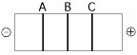
B) 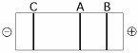
C) 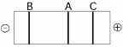
D) 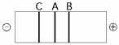
Bloom's Taxonomy: Application/Analysis
Section: 20.1
16. A principal problem with inserting an unmodified mammalian gene into a plasmid and then getting that gene expressed in bacteria is that _____.
A) prokaryotes use a different genetic code from that of eukaryotes
B) bacteria translate only mRNAs that have multiple messages
C) bacteria cannot remove eukaryotic introns
D) bacterial RNA polymerase cannot make RNA complementary to mammalian DNA
Bloom's Taxonomy: Synthesis/Evaluation
Section: 20.1

17. Why is it so important to be able to amplify DNA fragments when studying genes?
A) Before amplification, DNA fragments are likely to bind to RNA and no longer be able to be analyzed.
B) A gene may represent only a millionth of the cell's DNA.
C) Restriction enzymes (endonucleases) cut DNA into fragments that are too small.
D) A clone requires multiple copies of each gene per clone.
Bloom's Taxonomy: Knowledge/Comprehension
Section: 20.1

18. Which of the following can be duplicated in a genome?
A) only DNA sequences
B) only entire sets of chromosomes
C) only entire chromosomes
D) DNA sequences, chromosomes, or sets of chromosomes
Bloom's Taxonomy: Application/Analysis
Section: 21.5
19. It is more difficult to identify eukaryotic genes than prokaryotic genes because in eukaryotes _____.
A) the proteins are larger than in prokaryotes
B) the coding portions of genes are shorter than in prokaryotes
C) there are no start codons
D) there are introns
Bloom's Taxonomy: Knowledge/Comprehension
Section: 21.3

20. Why might the cricket genome have eleven times as many base pairs as that of Drosophila melanogaster?
A) Crickets have higher gene density.
B) Drosophila are more complex organisms.
C) Crickets must have more noncoding DNA.
D) Crickets must make many more proteins.
Bloom's Taxonomy: Synthesis/Evaluation
Section: 21.3

